Events on this Day –
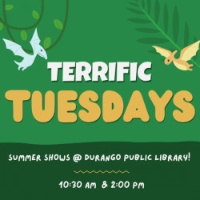
Tuesday, July 28th
Terrific Tuesdays: Summer Shows!
10:30am / Durango Public Library
Two performances; 10:30am and 2:00pm. Weekly summer performances for kids includes music, magic, animals, dinosaurs & more! Our Polar Bear Adventure:...

Juried Members Show (Tues - Sat)
12:00pm / Durango Arts Center - Barbara Conrad Gallery
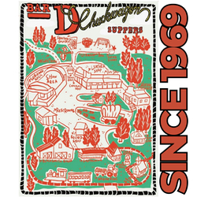
Local member artists have envisioned Colorado - the Next 150 years in a variety of media. The exhibit allows artists and audiences to imagine Colorado’s...
Bar D Chuckwagon Suppers
4:30pm / Bar D Chuckwagon Suppers
Old West Cowboy Music Show and Chuckwagon Supper! Durango's favorite family entertainment since 1969. Bar D Wranglers perform in concert after supper...
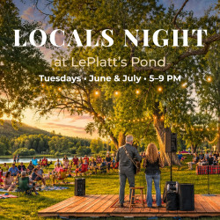
Locals Night at LePlatt's Pond
5:00pm / LePlatt's Pond at L-J Ranch
Enjoy live music, rotating food trucks, catch-and-release fishing, yard games, and time well spent with friends and family in a relaxed yet remarkable...
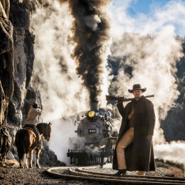
From Viking Fjords to the Rockies: David Yarrow Returns to Durango
5:00pm / Sorrel Sky Gallery
Sorrel Sky Gallery is delighted to welcome back world-renowned photographer David Yarrow. Fresh from a remarkable season of work abroad, Yarrow returns...
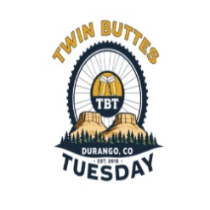
Twin Buttes Tuesday
5:30pm / Main Trailhead Parking Lot
Tuesday night group mountain bike ride at Twin Buttes. This ride leans intermediate to advanced, but if you’ve got legs and a sense of...

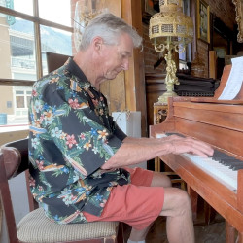
Darryl Kuntz
5:30pm / The Diamond Belle Saloon
Enjoy mellow and lively jazz as you watch local pianist, Darryl Kuntz play his favorites at The Diamond Belle Saloon.
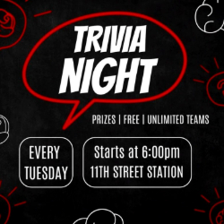
Tuesday Trivia
6:00pm / 11th Street Station
Join us for Trivia Night on the waterfall deck featuring weekly prizes as well as a weekly giveaway for $25 and $50 gift cards to Ernie’s Bar or The...
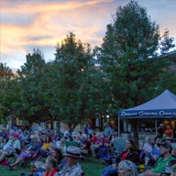
Music in the Plaza - Dave Mench
6:00pm / Three Springs Plaza
Join us for free Music in the Plaza. Open to the Public - Free to Attend
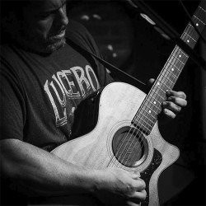
Rob Webster
6:00pm / The Office Spiritorium
Originally from Chicago-land, Rob is one of our favorite entertainers and also thinks The Office Spiritorium is one of the “coolest rooms in Durango!”...
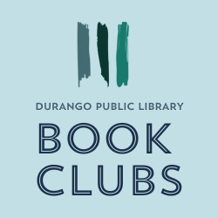
Cookbook Club: Secret Family Recipes
6:00pm / Durango Public Library
Let's get together and cook a potluck of recipes from our families! This month will be a little different than our usual Cookbook Club...
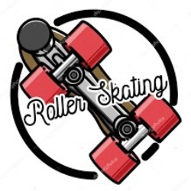
Adult Disco Roller Skating
6:30pm / Chapman Roller Rink
Come join your newly formed Durango Roller Skating Club this summer for adult roller jam. Come meet the members building community and groovy fun through...

Wednesday, July 29th

Wine, Beer, Spirits Tasting
4:00pm / Wagon Wheel Liquors
Weekly tasting at wagon Wheel. depending on the week we have either Wine, Beer, or spirits. Sometimes we have all three. Come in and taste something new...
Bar D Chuckwagon Suppers
4:30pm / Bar D Chuckwagon Suppers
Old West Cowboy Music Show and Chuckwagon Supper! Durango's favorite family entertainment since 1969. Bar D Wranglers perform in concert after supper...
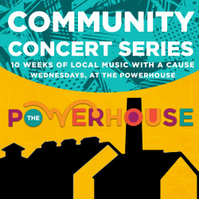
Community Concert Series ft. Ora
5:30pm / The Powerhouse
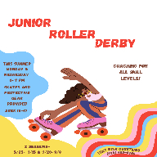
Join us for live music and community gathering with Carute Roma outside on the Carver Family Plaza! Ticket proceeds from this show support San Juan Citizens...
Junior Roller Derby
6:00pm / Chapman Hill
Coaching for all skill levels! Ages 10-17, Gear provided. $150 per session.

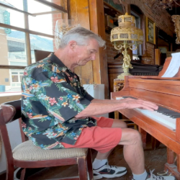
Darryl Kuntz
6:00pm / The Diamond Belle Saloon
Enjoy mellow and lively jazz as you watch local pianist, Darryl Kuntz play his favorites at The Diamond Belle Saloon.
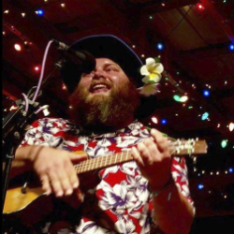
Devin Scott
6:00pm / The Office Spiritorium
Armed with a ukulele and a big, unexpected voice, Devin Scott easily entertains audiences of all ages. Performing everything from R. Kelly to Patsy Cline,...


Live Music with Leah Orlikowski
6:00pm / The Oxford
Leah Orlikowski is performing free live music at The Oxford.

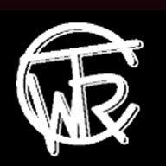
True Western Roundup - New Mexico Rodeo Assoc.
6:30pm / La Plata County Fairgrounds
Our mission is to produce events that preserve our western heritage, promote business, support human and animal athletes, build community and provide a...

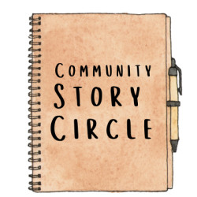
Community Story Circle
6:30pm / The Durango Public Library
With local author and life coach, Brooke Heller. At each monthly meeting, Brooke shares a prompt, we journal about it, then we share our...


The (Almost) Weekly Comedy Open Mic
7:00pm / American Legion
An (almost) weekly open mic for comics and comedy lovers alike. Come perform, come watch, come support your local Durango comedy community. 7:00–8:00pm...
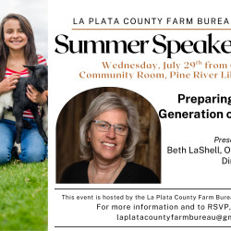
Preparing the Next Generation of Agriculture - Summer Speaker Series
7:00pm / Pine River Library - Bayfield's Public Library
? We're pleased to welcome Beth LaShell of Fort Lewis College. Beth will share her experience developing future agricultural leaders and discuss ways...

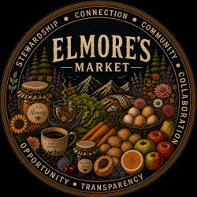
Thursday, July 30th
Elmore's Farmers Market
8:00am / 306 Florida Grange
Created through collaboration, Elmore’s Farmers Market is a community-driven, vendor-led market where connection and core values come before commerce,...
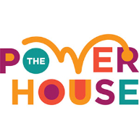
Toddler Summer Gardening Program
9:30am / The Powerhouse
Join us at The Powerhouse either Monday or Thursday mornings throughout the summer to learn about the Power of Plants in our backyard garden beds. Led...

Sip & Stitch - Craft and Wine
4:00pm / Durango Winery
Bring a craft to work on and get 25% off glasses of wine. Please no projects involving paint or glitter.
Bar D Chuckwagon Suppers
4:30pm / Bar D Chuckwagon Suppers
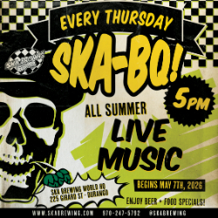
Old West Cowboy Music Show and Chuckwagon Supper! Durango's favorite family entertainment since 1969. Bar D Wranglers perform in concert after supper...
Ska BQ: Live Music & Beer Specials
5:00pm / Ska Brewing
Meet us in the beer garden with yer dancing shoes & drinkin' pants - it’s SKA-BQ time! Live tunes from local & visiting artists...
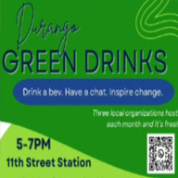
Durango Green Drinks
5:00pm / 11th Street Station
Join Durango Green Drinks - the last Thursday of every month from 5-7PM with three different local sustainability organizations hosting each month. It's...
Live Music with Leah Orlikowski
5:00pm / El Rancho Tavern
Leah Orlikowski is performing free live music at El Rancho Tavern.
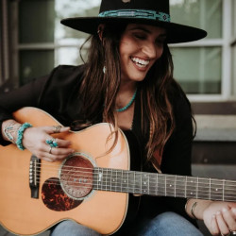
Concert Hall @ The Park featuring Jessee Lee
5:30pm / Buckley Park
Texas-based, Nashville recording artist bringing a vintage country-soul sound shaped by a sharp pen and soulful voice. Settle in for a summer...

Dart Tournament
5:30pm / Union Social House
Whether you're a seasoned pro or just looking for some friendly competition, come test your aim, meet fellow dart enthusiasts, and enjoy a great time. Sign-ups:...
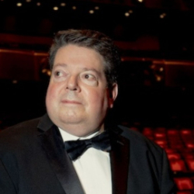
Andrew Litton, A Life in Music - Music in the Mountains Benefit Dinner & Concert
6:00pm / Strater Hotel
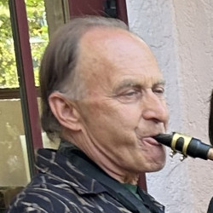
Treat yourself to an exclusive evening with one of the greatest conductors on the concert circuit, 2026 Conductor-in-Residence, Andrew Litton. As it turns...

Jeff Solon Jazz
6:00pm / Lola's Place
Live jazz on the patio! Jeff plays tenor saxophone, harmonica, and flute and is joined by different musicians each week. Duo's and groups. Jazz Standards,...
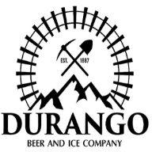
Bluegrass Jam
6:00pm / Durango Beer and Ice Company
Local bluegrass musicians gather to pick and play great bluegrass music. Join us for award winning beer and the great Americana sounds from Durango's...

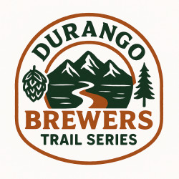
Durango Brewer's Trail Race Series
6:00pm / Test Tracks
Three Trails. Three Breweries. One Epic Summer. Welcome to the Durango Brewers Trail Series—a high-energy, community-driven trail running...
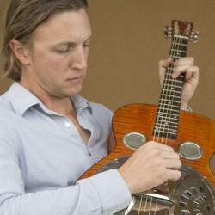
Sean O'Brien
6:00pm / The Office Spiritorium
Sean grew up playing many different instruments, none of which has fascinated him as much as the guitar. He began playing guitar in 2001 in Ojai, CA, and...
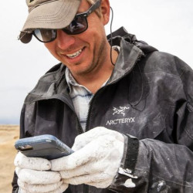
Stories Written in Stone: A Life in Paleontology
6:00pm / The Durango Public Library
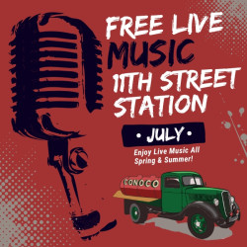
With local Paleontologist John Hankla Join John as he shares how scientists decode Earth’s ancient past by interpreting fossils and rock...

Live Music with Rockin Randy
6:00pm / 11th Street Station
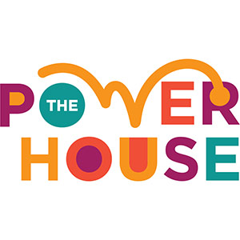
11th Street Station features local and touring artists performing music from many genres. We invite you to join us for live music in downtown Durango this...

Trivia Night Outside on the Plaza
6:30pm / The Powerhouse
Join us outside on the Carver Family Plaza. Five rounds of questions always including a science round and music round. Teams of five eligible for prizes,...
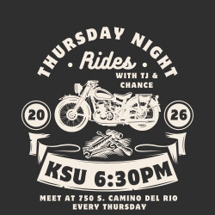
Thursday Night Rides
6:30pm / Durango Harley-Davidson
Rides with TJ and Chance are back! Join us this Thursday for an evening group ride filled with great company, good vibes, and open roads. Kickstands...

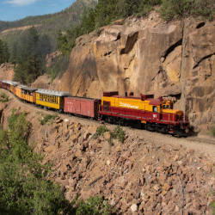
Friday, July 31st

Scenic Round Trip Silverton Train (Diesel)
8:00am / Durango and Silverton Narrow Gauge Railroad
Enjoy a leisurely trip to yesteryear riding 3 1/2 hours each way on this diesel train plus spend 2 hours in the historic mining town of Silverton to enjoy...

Veterans Friday Morning Coffee
8:00am / American Legion Post 28
Please join us for coffee and refreshments (Doughnuts) Families and Veteran caregivers welcome. Free no cost Just...

VOA Chocolate Fantasia Fundraising Competition - final day to enter
8:00am / Durango Community Shelter
Volunteers of America Colorado is seeking dessert artisans to compete in Chocolate Fantasia, a fundraising event benefiting the Durango Community Shelter...
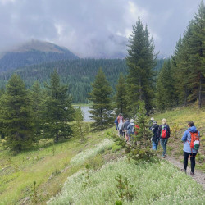
San Juan Nature Hike
10:00am / Andrews Lake
Want to know more about nature? Flora, fauna, geology, clouds, water, you name it: our trusty crew of volunteer naturalists can enlighten you while on...
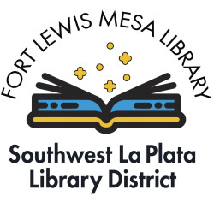
Pokemon Club
1:00pm / Fort Lewis Mesa Library
Pokemon Club at Fort Lewis Mesa Library. Learn how to play, show off your collection, and trade with others. Free. For ages 7 and up.

Bar D Chuckwagon Suppers
4:30pm / Bar D Chuckwagon Suppers
Old West Cowboy Music Show and Chuckwagon Supper! Durango's favorite family entertainment since 1969. Bar D Wranglers perform in concert after supper...
Live Music with Leah Orlikowski
5:00pm / El Rancho Tavern
Leah Orlikowski is performing free live music at El Rancho Tavern.
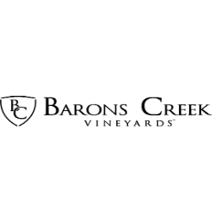
Live Music with Pete Giuliani
5:30pm / Barons Creek Vineyards Durango
Join us for wine, food, music, and fun every Friday night!
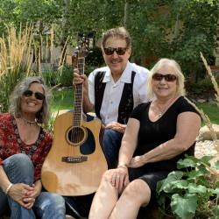
Three Way Street
6:00pm / Union Social House
Three Way Street brings iconic classics to life with a high-energy live show built for singing along. From timeless rock and pop favorites to unforgettable...
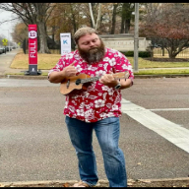
Friday Nights at Fox Fire
6:00pm / Fox Fire Farms Winery
Live music with and food every Friday night this summer in a beautiful vineyard and farm setting. Free admission.
Darryl Kuntz
6:00pm / The Diamond Belle Saloon
Enjoy mellow and lively jazz as you watch local pianist, Darryl Kuntz play his favorites at at The Diamond Belle Saloon.
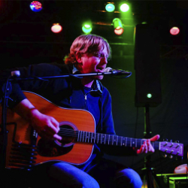
Dustin Burley
6:00pm / The Office Spiritorium
Dustin’s music is a blend of Outlaw Country/Blues/Classic Rock/Folk. He puts his own twist on old classics and blends his original songs through his...

Live music with Matt Rupnow
6:00pm / Lola's Place
Free concerts - come and enjoy live music on our patio 3 evenings a week. Enjoy a refreshing beverage or bar bite, with salami or salmon...
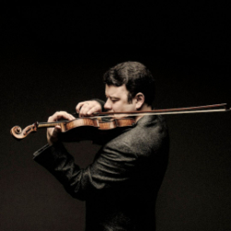
Gluzman Plays Bruch - Music in the Mountains Orchestra Concert
7:00pm / Community Concert Hall at Fort Lewis College
Experience an incredible evening of moving music, featuring a very special piece! In honor of the 250th and 150th anniversaries, O Beautiful Unity is a...
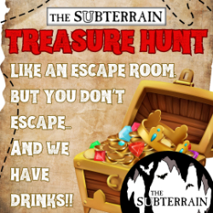
Treasure Hunt
7:00pm / The Subterrain
It’s like an escape room only you don’t escape, and we have drinks! Follow the clues and beat the clock to find the treasure. Most Fridays. Must...
Live Music with Agave
7:00pm / 11th Street Station
11th Street Station features local and touring artists performing music from many genres. We invite you to join us for live music in downtown Durango this...

